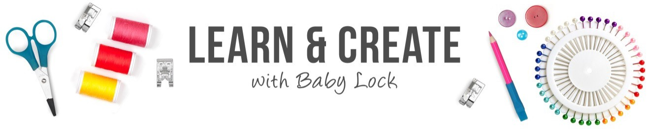
Reusable Popcorn Bag

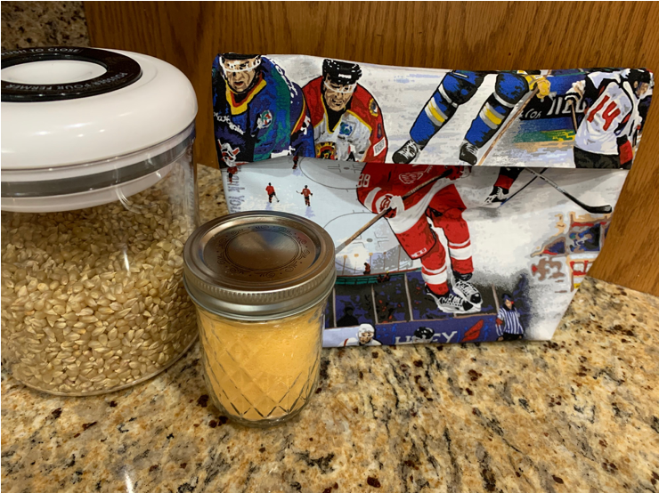

Create a reusable popcorn bag with this fun project tutorial. With only a few basic supplies and a serger or sewing machine, you will be enjoying a delicious bowl of popcorn in no time at all.

Skill Level: Beginner

Created by: Denise Schober

Supplies:
Baby Lock Serger with Overlock capabilities or Sewing Machine with ¼” Foot
(1) 12 ½” x WOF (width of fabric) 100% cotton fabric
(3) Coordinating spools of cotton thread such as Madeira Cotona
Wonder Clips
Point Turner
Rotary Cutter
Ruler
Mat
Popcorn Kernels
Popcorn Salt
Microwave

Preparation:
- Tip: Do not use metallic prints as they may harm your microwave or batiks as the wax could melt.
- Serger Option: thread Baby Lock Serger for 3 Thread Overlock Wide, Stitch Selector – A, Stitch Length – 2.5, Stitch Width – M.
- On a scrap of fabric, test stitch and measure seam allowance. These settings should yield a ¼” seam allowance, adjust Stitch Width if necessary

Construction:
- Fold fabric in half right sides together and secure with Wonder Clips.
- Stitch along 3 open edges leaving a 3” opening on one side for turning.
- Turn right sides out, use point turner to create nice corners and press.
- Fold in half bringing the bottom edge 3” down from top edge.
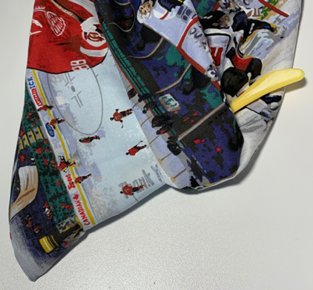
- Fold the top 3” over the bottom hem line and press to set.
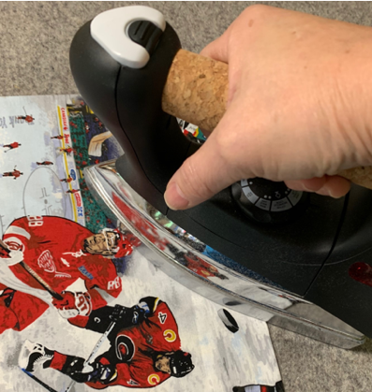
- Stitch both side seams using 1/4” seam allowance and secure beginning and end of seams and press to set.
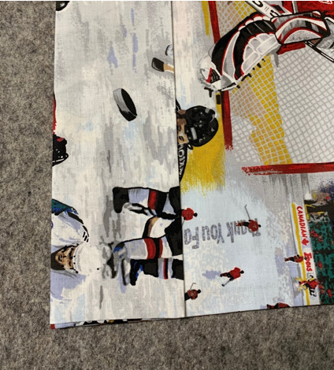
- Box bottom corners by aligning bottom folded edge with one side seam, this will form a point.
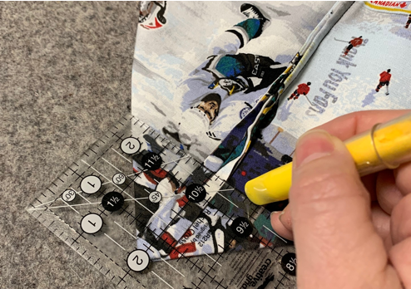
- Measure 2” up from point and mark a line across the side seam.
- Stitch on marked line then trim off excess fabric in the point.
- Repeat with second side.
- Turn right sides out and press

Make Popcorn!
- Place ½ cup popcorn kernels in bag.
- Add Popcorn Salt to taste.
- Set Microwave for 4 minutes and turn on.
- Once popping slows, remove from Microwave.
- Serve in bowl or reusable bag and enjoy your tasty treat!

*Tip: Do not walk away! Microwave heat varies so popping time will vary, prepare to remove popcorn from microwave before 4 minutes have elapsed

For other exciting projects like this one, visit Baby Lock at www.babylock.com.

©2020 Baby Lock USA. This project may be freely used by individuals for non-commercial purposes. Project instructions may not be sold or distributed without approval from Baby Lock. Baby Lock must be acknowledged as the source of the project instructions through copyright or online link

