Personalized Beach Tote

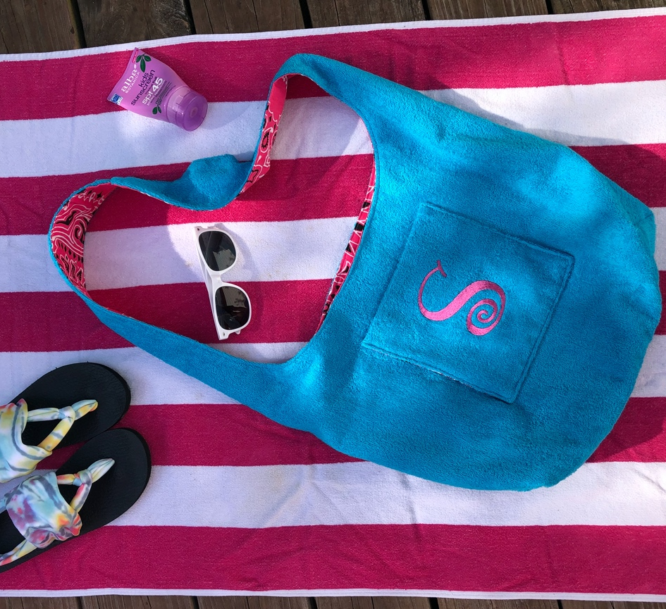

Transform a bath or beach towel into a personalized beach tote! It is the perfect accessory for summer activities at the pool, the beach or the lake.

Created By: Stephanie Struckmann

Skill Level: Beginner

- Supplies:
- Baby Lock Sewing Machine
- Baby Lock Embroidery Machine
- 1 Yard of terry cloth or large towel
- 1 Yard of woven cotton lining fabric
- Bag pattern template provided below
- Tape
- Madeira Aerofil or All-Purpose sewing thread
- Madeira Rayon or Polyester embroidery thread
- Baby Lock Tear Away Firm Stabilizer (BLT103)
- Baby Lock Press-Away Topping (BLP-FILM)
- Temporary Adhesive Spray
- Scissors
- Pins and basic sewing notions
- Iron and Pressing Mat

- Instructions:

- Print the bag pattern pieces.
- Tape your pattern together. Using your pattern, cut one on the fold from the terry cloth and one on the fold from the lining fabric.
- For the pockets, cut three 9” x 9” squares from the lining fabric and one 9” x 9” square from the terry cloth.
- Hoop the 9” terry fabric with tear away firm stabilizer. If desired, spray stabilizer with temporary spray adhesive. Cut and place a piece of Press-Away topping on the top of the hoop.
- For this project, we recommend the 130mm x 180mm (5” x 7”) hoop size.
- Place the hoop on the machine.
- Retrieve the design from the flash drive.
- Combine, rotate and edit the design as needed for the bag pocket.
- Align your design with the pocket front.
- Embroider the design
- Remove the hoop from machine and gently remove from the hooped stabilizer from the back.
- Remove the bulk of the press-away topping. Press away the remaining topping by moving the iron in a circular motion. You could also use Hydro-Melt topping for this type of project and use water to remove excess topping.

- Bag Construction

- To stitch the pockets together, match two lining squares pretty sides together and stitch only three sides leaving the bottom edge open. Then, match the embroidered terry cloth with one lining square pretty sides together and stitch three sides leaving the bottom edge open.
- Clip the corners, turn, and press the pockets. Then, press under ½” on the raw edges on each.
- Mark 2-3” down on the center front of the bag on the terry cloth and the lining. Place the to of the pocket even with this mark and topstitch close to the edge along three edges, leaving the top open.
- Now stitch the center back seam using a ½” seam allowance. Press open.
- Turn wrong sides out and match the center front and center back seams. Stitch the lower edge of the back completely on the terry cloth, but, leave a 6” opening in the center of the lining for turning.
- To box out your corners, flatten each corner of the bag, matching the folds of the sides to the bottom seam on the bag. Measure up 2” from that point and draw a line perpendicular to the measurement line. Stitch along this line and trim excess fabric.
- Take both pieces and place one inside the other, pretty sides together. Pin the outer u shapes of the straps completely. Start with the center fronts/backs and the top of the straps, easing the terry cloth to fit the lining fabric. Then, stitch a ½” seam allowance all the way around both u-shaped edges.

- Tip: Stitch with the terry cloth against the feed dogs on your sewing machine so that it pulls the bulky fabric through better.

- Clip your curves after stitching
- Next, turn one strap in through the inside of the bag between the outer and lining layer and up through the opening in the lining.
- Press the seam allowances nicely along the strap only.
- Then, push it back into the lining and all the way up through and into the inside of the other strap. Make sure the inside strap is not twisted and that the right sides are together.
- Align the raw edges of all four layers (two terry cloth layers and two lining layers) and stitch a ½” seam allowance along the short edge. Trim away the bulk.
- Now pull the straps out through the opening in the lining as well as the rest of the bag.
- Turn it rights side out.
- Press the rest of the strap and lining to the inside of the bag.
- Finally, pull the lining opening out and stitch the opening to enclose the lining.

For other exciting projects like this one, visit our website at www.babylock.com

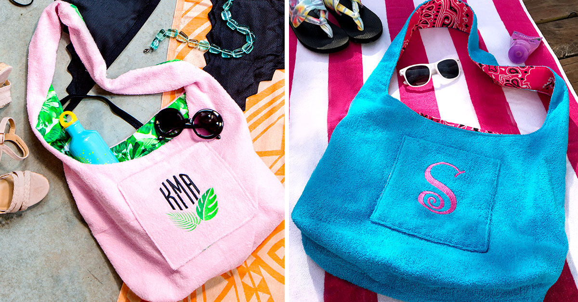

©2020 Baby Lock USA. This project may be freely used by individuals for non-commercial purposes. Project instructions may not be sold or distributed without approval from Baby Lock. Baby Lock must be acknowledged as the source of the project instructions through copyright or online link.

