Serger Fabric Flowers

We hope you enjoyed the Facebook Live on how to make Serger Fabric Flowers. Here are some specifics to help you make these at home.

Ribbon Flowers:

Ribbon flowers are fun to make. Experiment with all sorts of ribbon to create your unique flowers. To add some pizzazz to your flowers, consider adding a decorative serger stitch to one edge of the ribbon. Use fun decorative threads in the upper and lower loopers and stitch a rolled hem, 3-thread wide or even an exclusive Baby Lock Wave stitch to enhance the look of your flower. Layer two ribbons together as well for a creative twist to your flowers.

Supplies needed:

1 yard of Grosgrain or Satin Ribbon (ribbon width optional0
1 yard of 26- gauge wire or floral wire
3 cones Madeira Serger Thread
Baby Lock 4-thread or 8-thread Serger
Baby Lock Elastic Foot or Beading Foot for Serger
12 wt. Decora thread (for decorative edging of ribbon)
Wire Cutters

Instructions:

- Set up the machine for a 3-Thread Narrow Stitch.
- Thread the Serger using the Madeira Serger Thread.
- Set the Stitch Width at 5.0 and the Stitch Length at 4. Differential Feed at 2.
- For this technique, locking the blade may also be desired so you don’t cut the edge of the ribbon.
- Cut a piece of the 12 gauge wire the length of the ribbon
- Insert the wire into guides on the left side of the foot.
- Attach the Elastic Foot to the Serger
- Tip-turn the handwheel towards you to catch the wire before you get stitching.
- Lay ribbon under the foot.
- Serge along the edge ensuring that the wire is encased in the serged stitches.

- After stitching along the entire edge, use the wire to further gather the ribbon.
- Form the gathered ribbon into a flower shape.

Fabrics Flowers:

If you don’t have ribbon in your stash, you can always use fabric to create flowers. This allows you to also make larger, fuller flowers that are fun to embellish! The technique is similar to the ribbon flowers. Decorative stitching can again add to the look of your flowers. Think outside the box on what could be used to create flowers. Burlap, lace, wool or wool felt, taffeta or home décor fabrics could make some fun flowers. Pre-cut fabric strips also can make for each flower construction. Place two fabrics together to add a unique look. Consider adding buttons or other embellishments for decoration with your flowers.

Supplies needed:

2/3 yard of miscellaneous fabric for fabric flowers
26- gauge wire or floral wire cut to WOF
3 cones Madeira Serger Thread
Baby Lock 4-thread or 8-thread Serger
Baby Lock Elastic Foot or Beading Foot for Serger
12 wt. Decora thread (for decorative edging of ribbon)
Wire Cutters
Rotary cutter, ruler and mat
Iron and pressing mat
Optional: Felt fabric for attaching the fabric flowers
Optional: Baby Lock Ultra Soft Stabilizer BLC204 or Terial Magic & Best Press mixture to help add body to fabric.

Instructions:

- Cut 2 strips by the width of the fabric.
  - For the samples shown in the FB Live, the strips were cut 6” and “ by WOF.
- To help stabilize the fabric flowers, you can fuze the Ultra Soft fusible stabilizer the cut length of the strip or spray and press with a mix of Terial Magic and Best Press
- Fold in the side edges and then fold the fabric in half lengthwise.
- Set up the machine for a 3-Thread Narrow Stitch.
- Thread the Serger using the Madeira Serger Thread.
- Set the Stitch Width at 5.0 and the Stitch Length at 4. Differential Feed at N.
- For this technique, unlock the blade.
- Cut a piece of the 12 gauge wire the length of the fabric
- Insert the wire into guides on the left side of the foot.
- Attach the Elastic Foot to the Serger
- Tip-turn the handwheel towards you to catch the wire before you get stitching.
- Lay cut edge of the folded fabric under the foot.
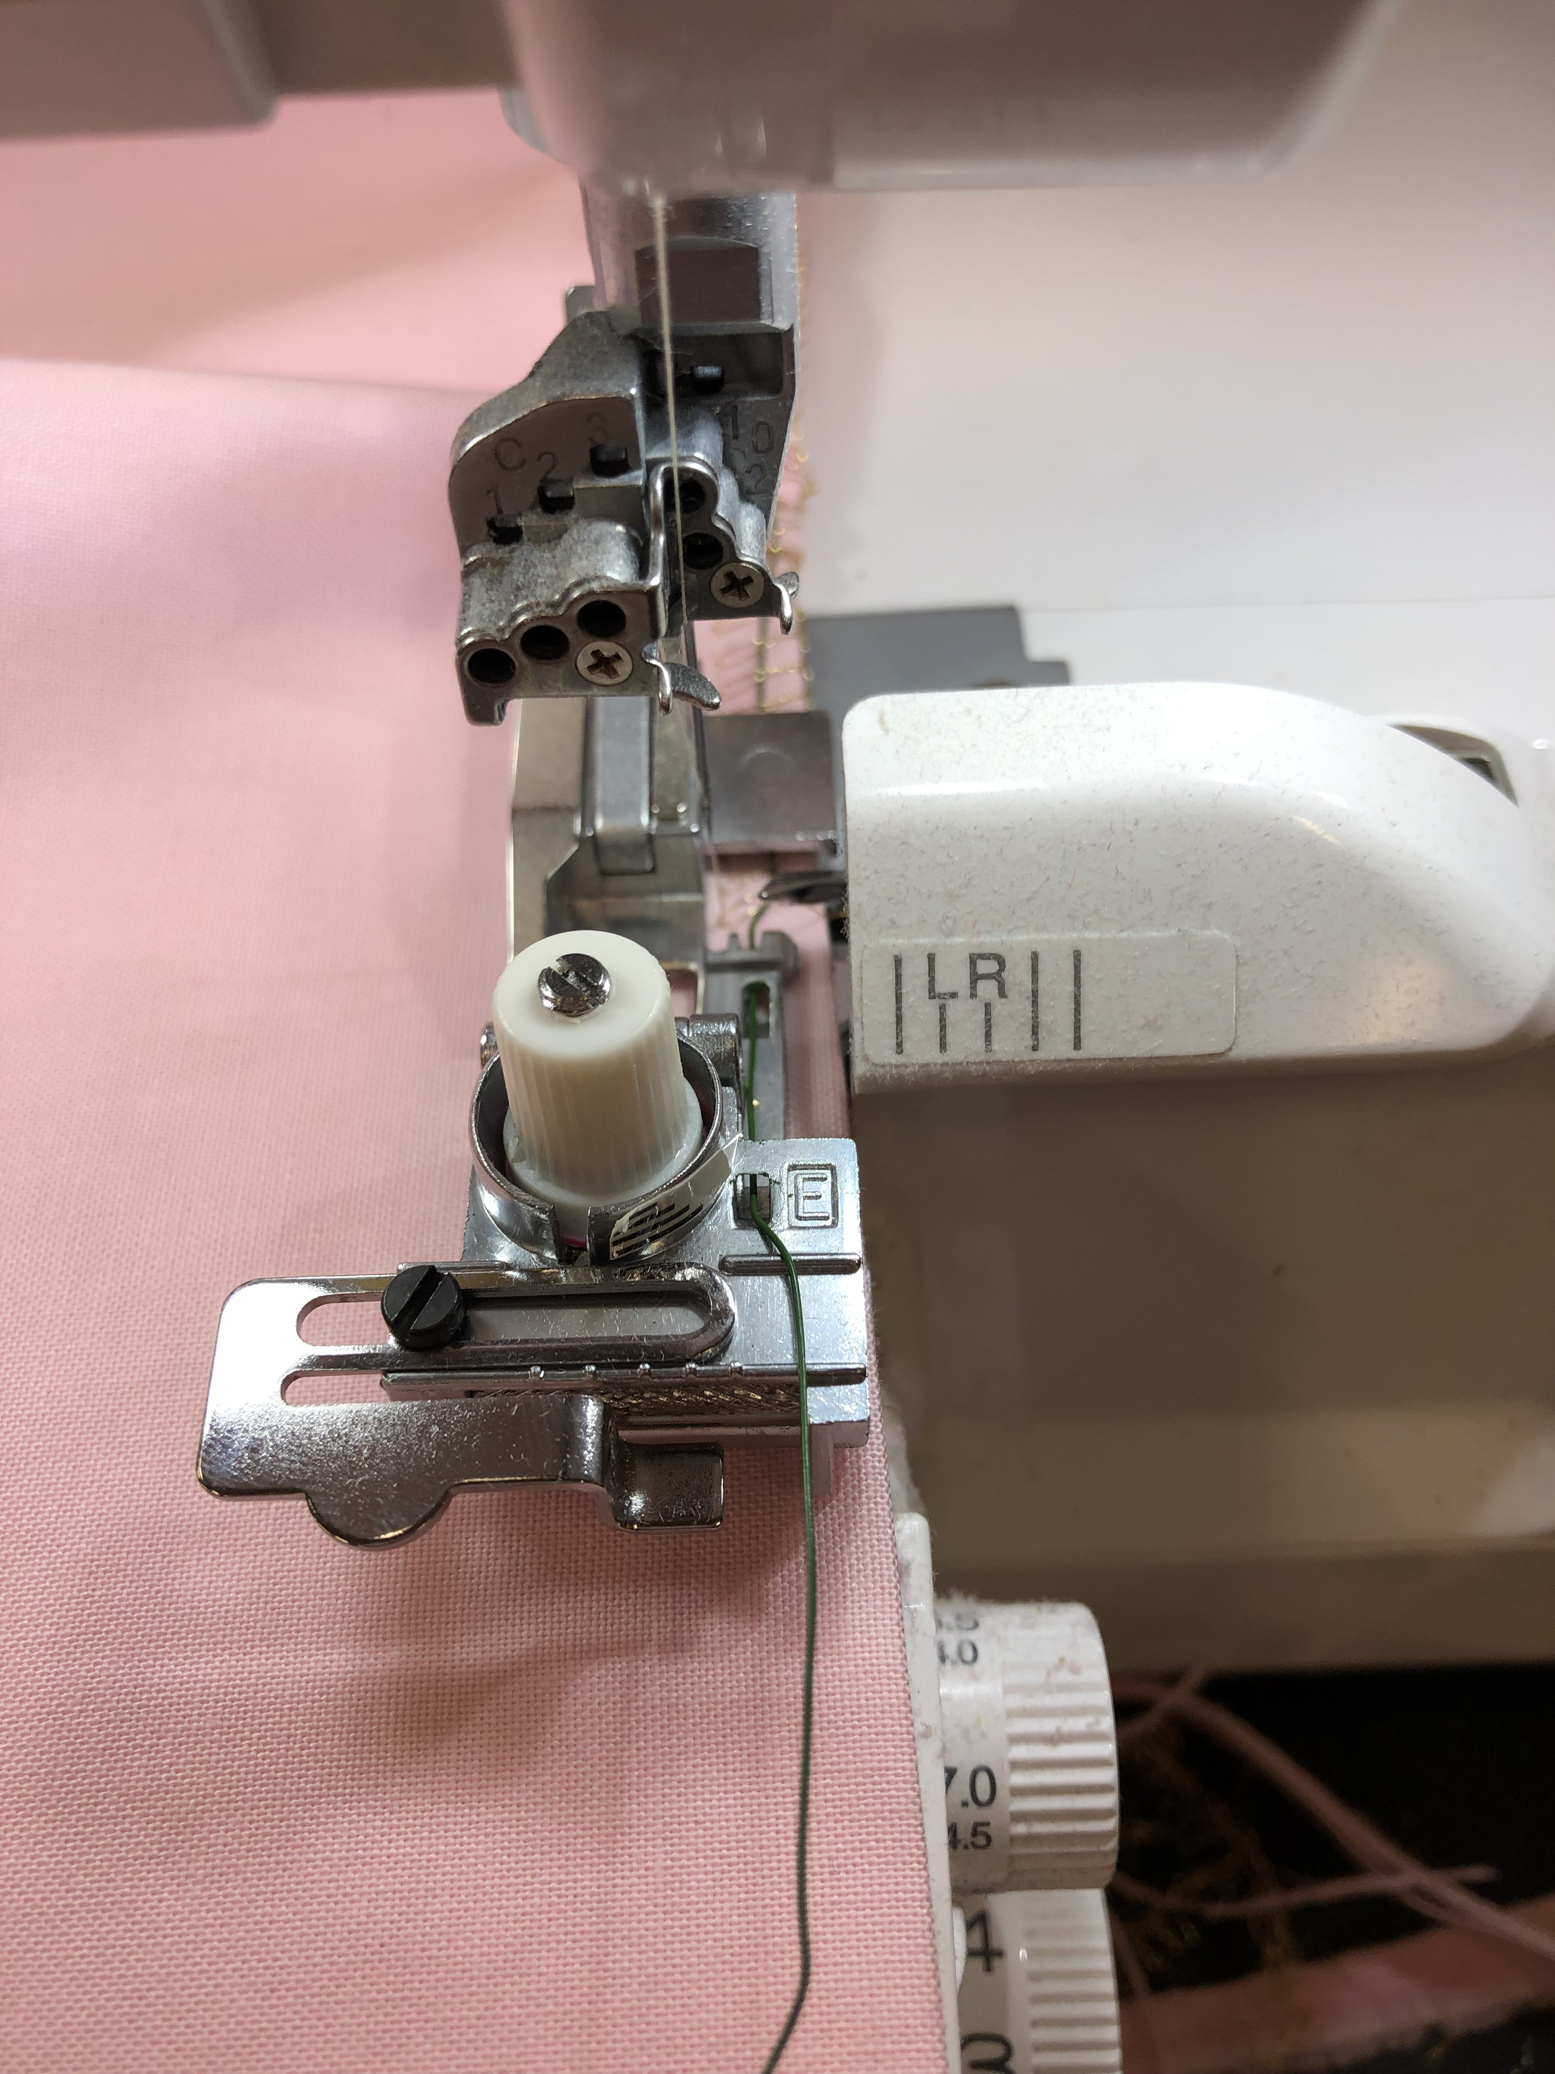
- Serge along the edge ensuring that the wire is encased in the serged stitches.
- Tip: You can add gathering to the flowers by folding the wire over the end of the starting flower edge. Then pull slightly on the wire to gather while stitching. This will save on the amount of wire needed.
- After stitching along the entire edge, use the wire to further gather the fabric
- Form the gathered fabric into a flower shape.
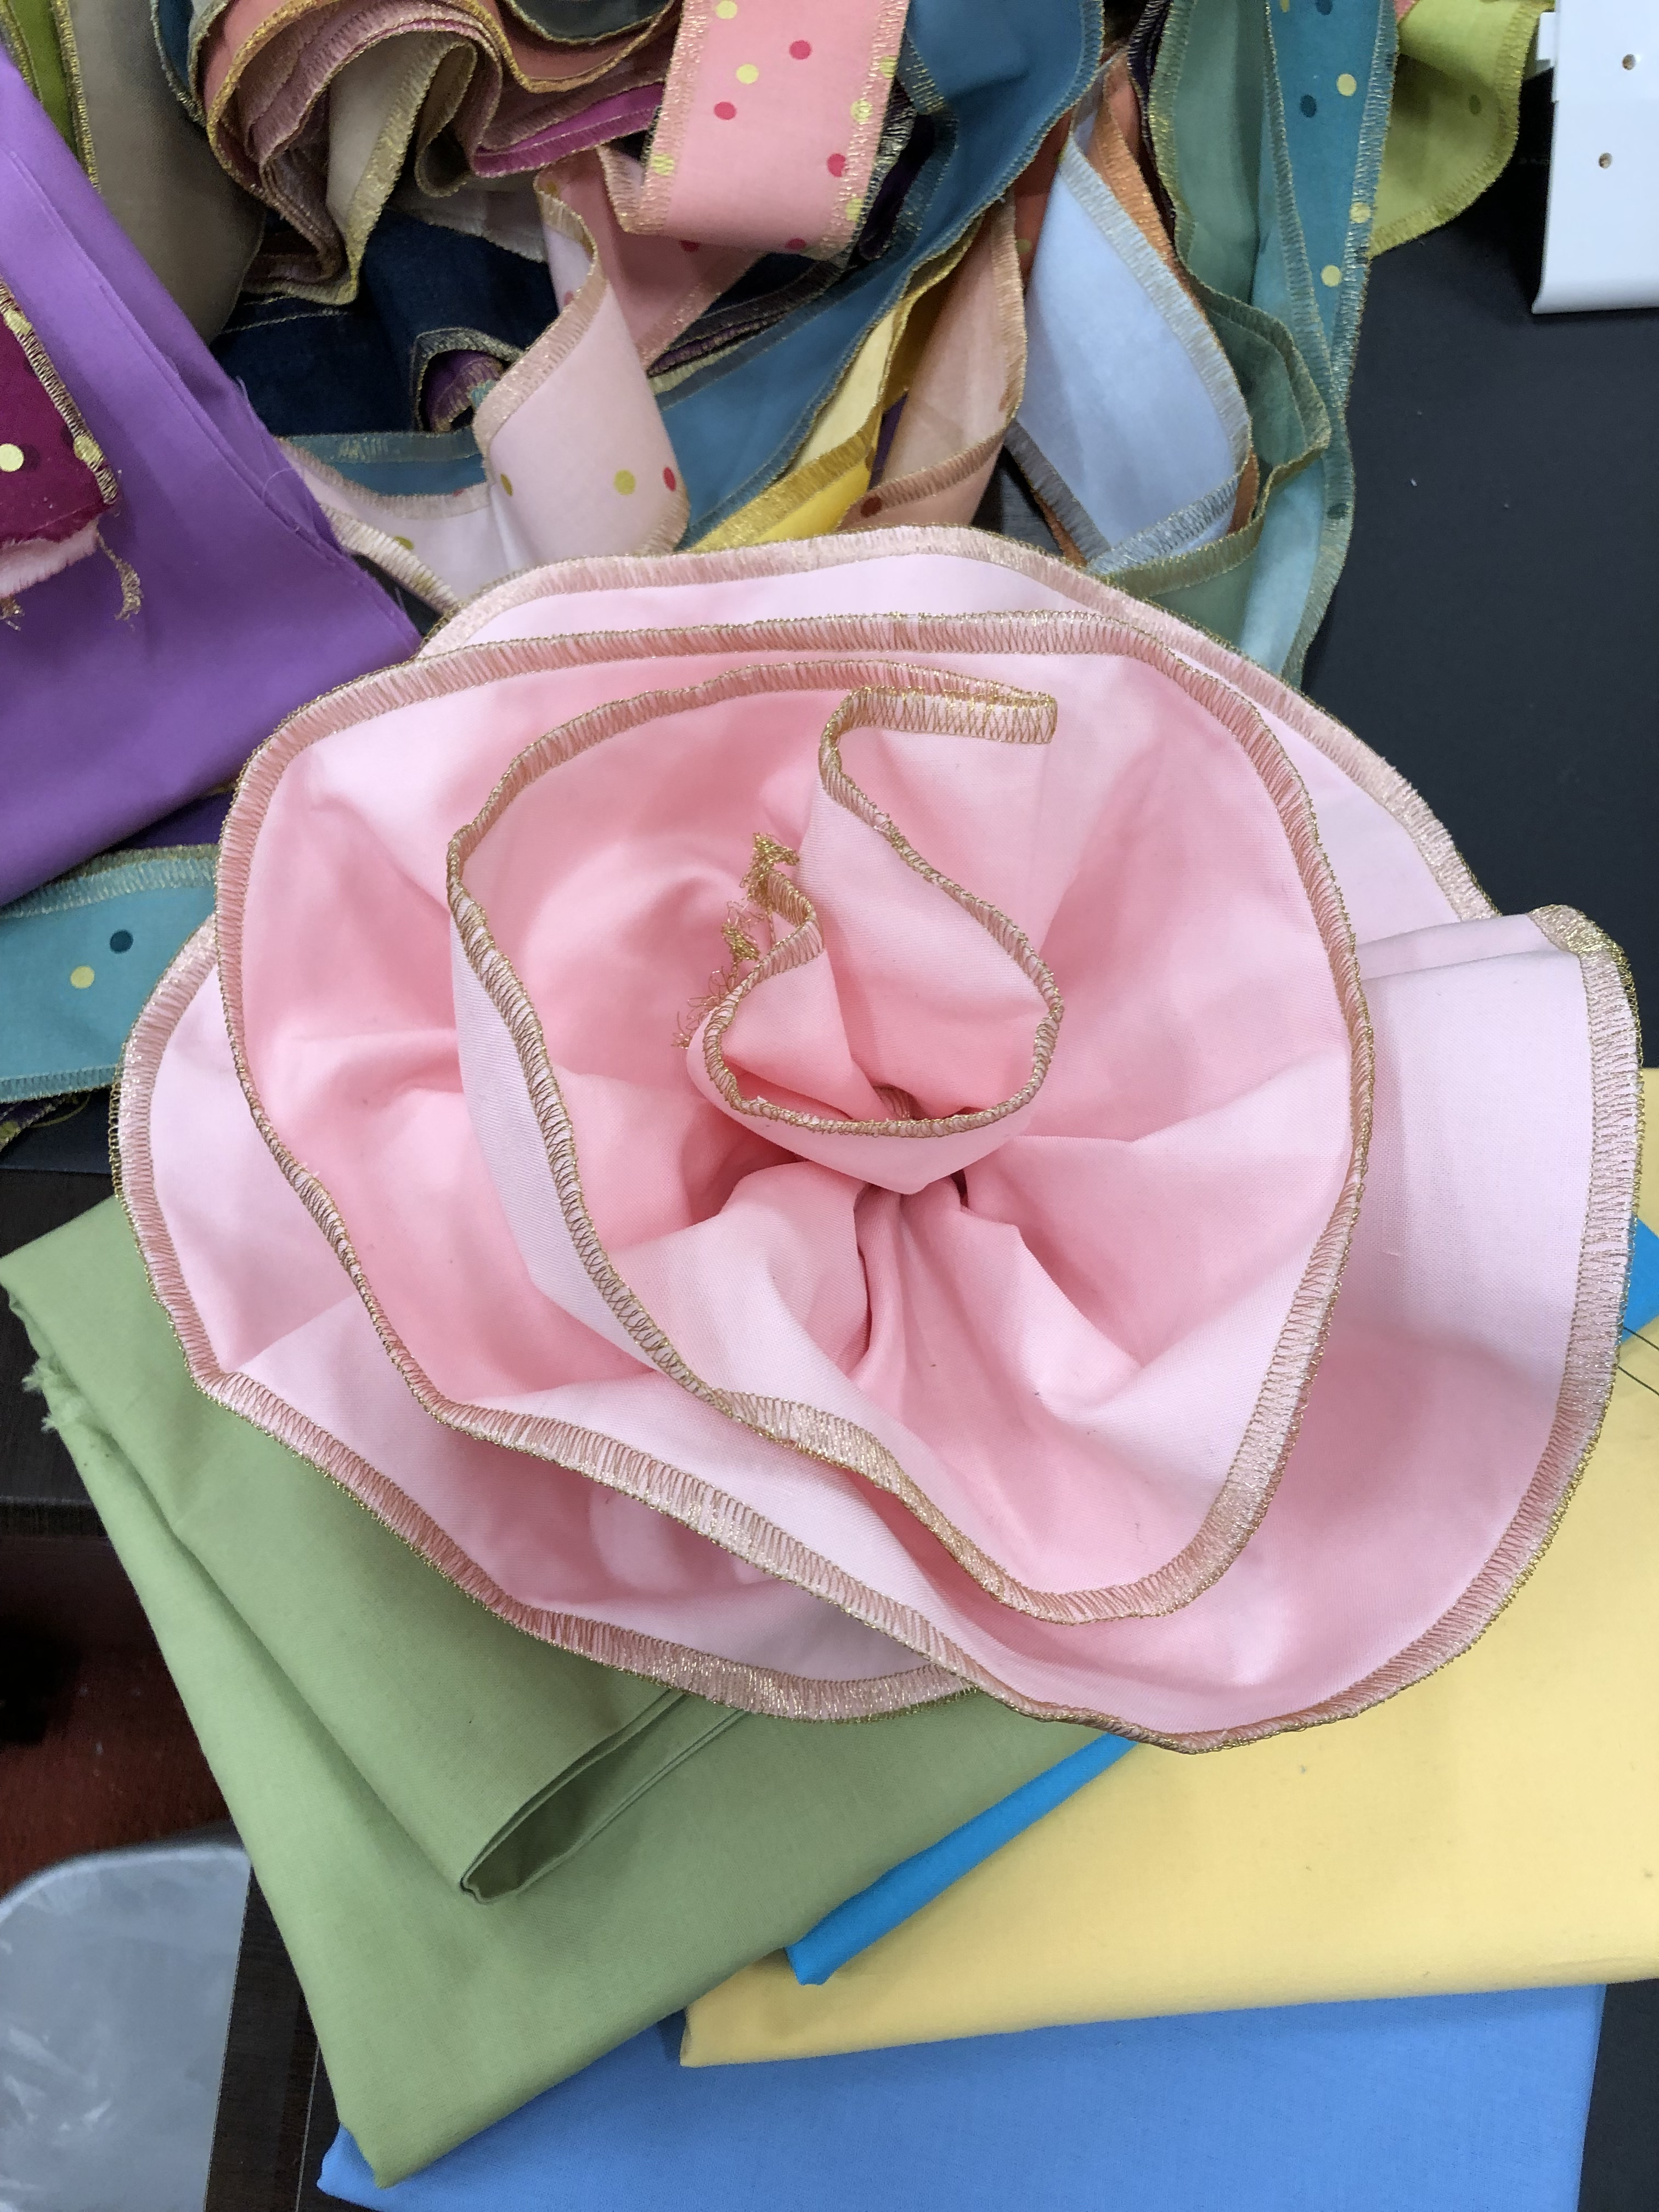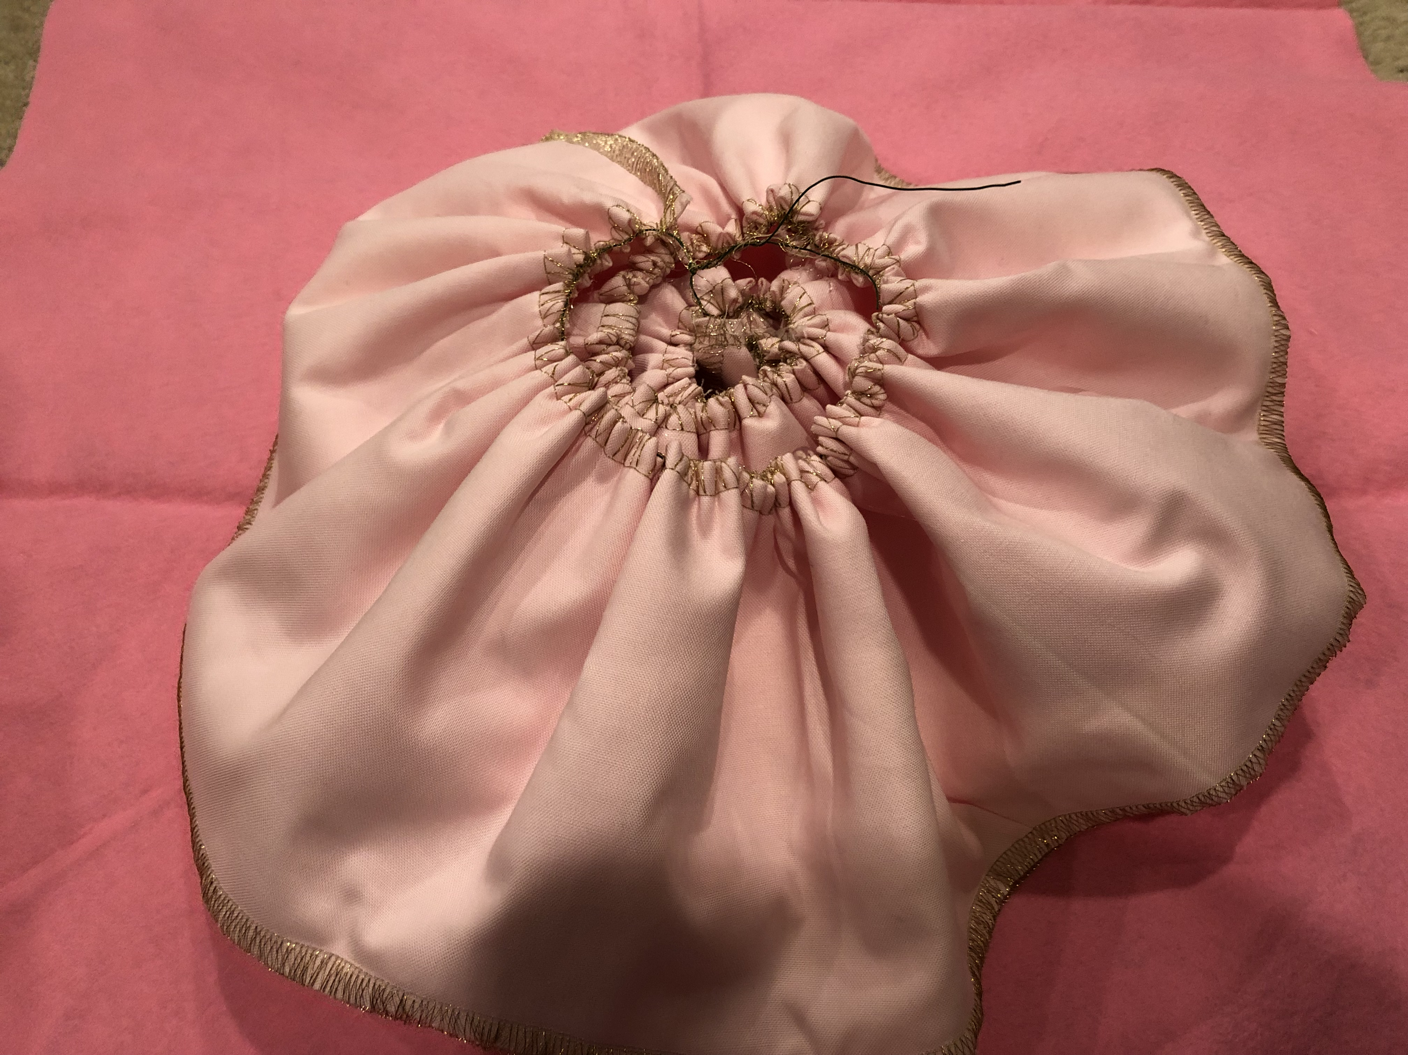
- Either hand-sew or hot glue the gathered fabric to secure the flower shape. These can be attached to a piece of felt to assist with keeping the flower shape.
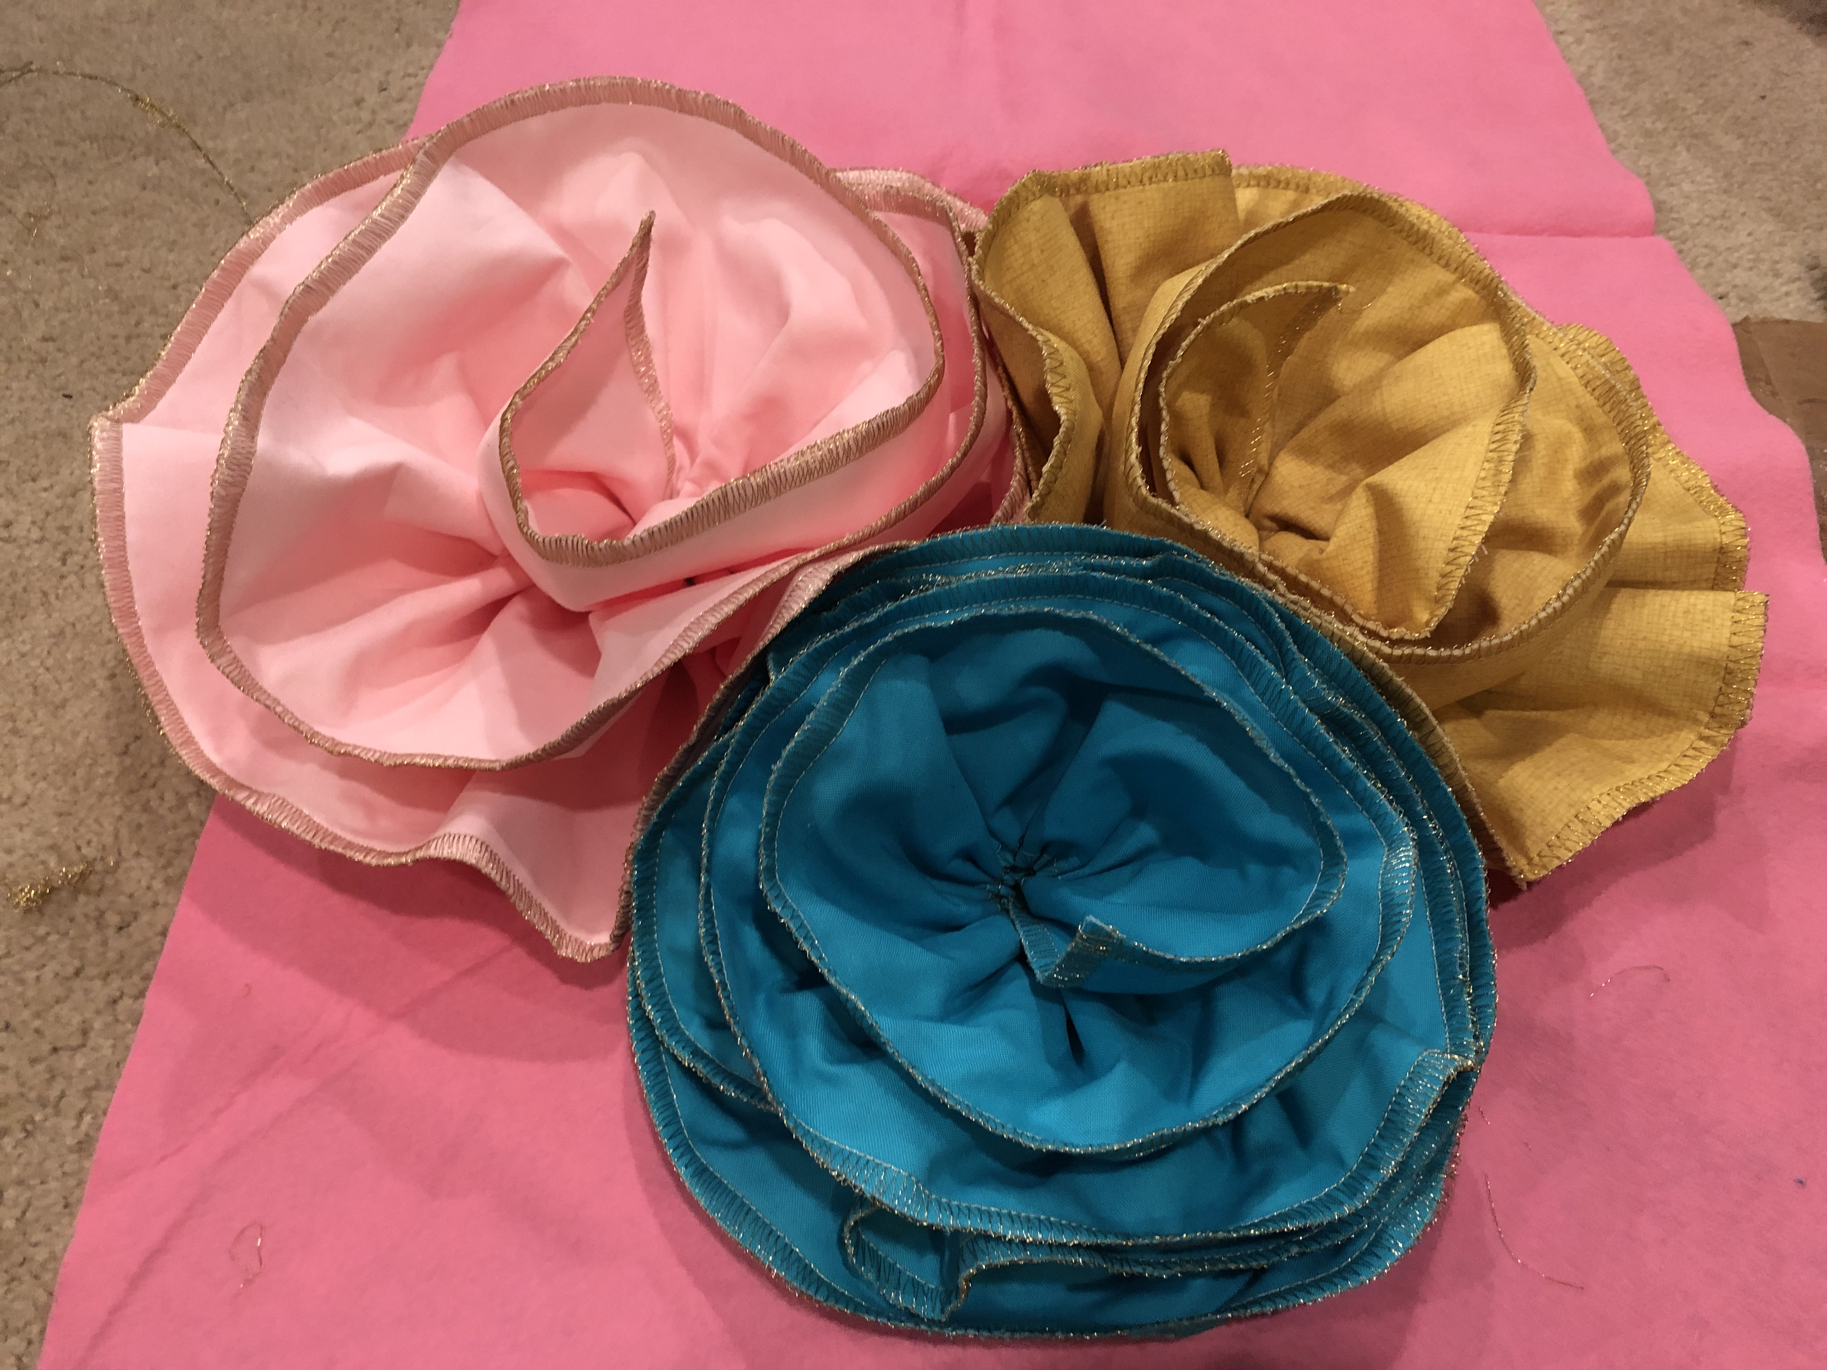

Samples Shown:

Flower Bouquet with Ribbon Flowers
Flower Vase with Batik Ribbon Flowers
Easter Banner with Lace Flower
Serger Table Runner with Flower Embellishment
Wreath with Fabric Flowers
Flower Ribbon Brooch

